**Data Structures and Algorithms**

**Lab Report**

**Lab04**



|  |  |
| --- | --- |
| Group Members Name & Reg #: | **Muhammad Haris Irfan**  **(FA18-BCE-090)** |
|  |  |
| Class | Data Structures and Algorithms CSC211 (**BCE-3B**) |
| Instructor’s Name | Dilshad Sabir |

**In Lab Tasks**

**Task:1**

**Debugging code for errors.**

**Solution:**

I debugged the code and resolved the issues, the code had four syntax errors with the prototypes.

-------------------------------

**Task:2**

**Implementing Node Removal and Node Insertion Tasks**

Solution

The code is shown below,

DELETING FROM THE BEGINING

The code is shown below,

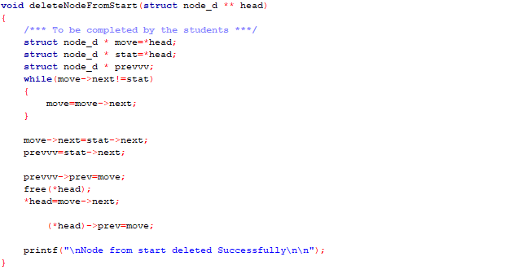

The Result of the following code is attached below:

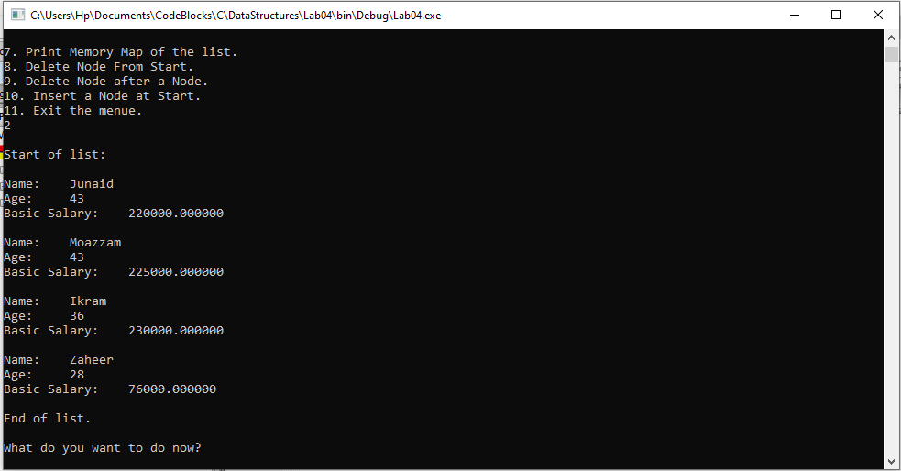

**DELETING AFTER A NODE**

The code is shown below,

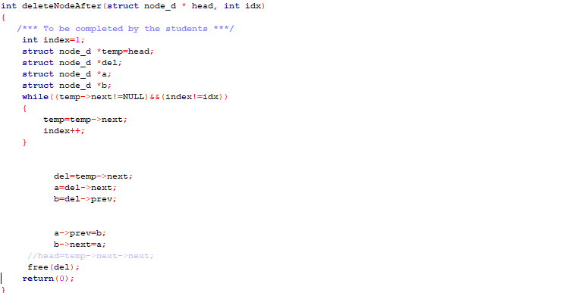

The Result of the following code is attached below:

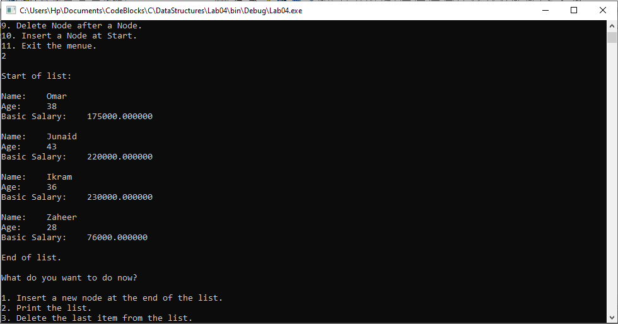

**INSERT A NODE AT START**

The code is shown below,

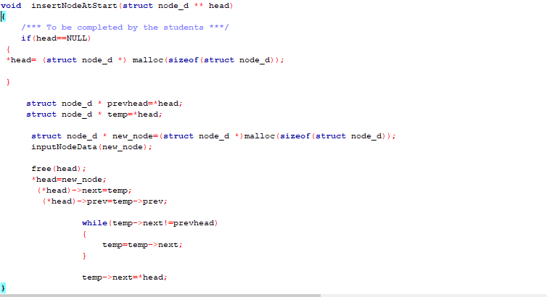

The Result of the following code is attached below:

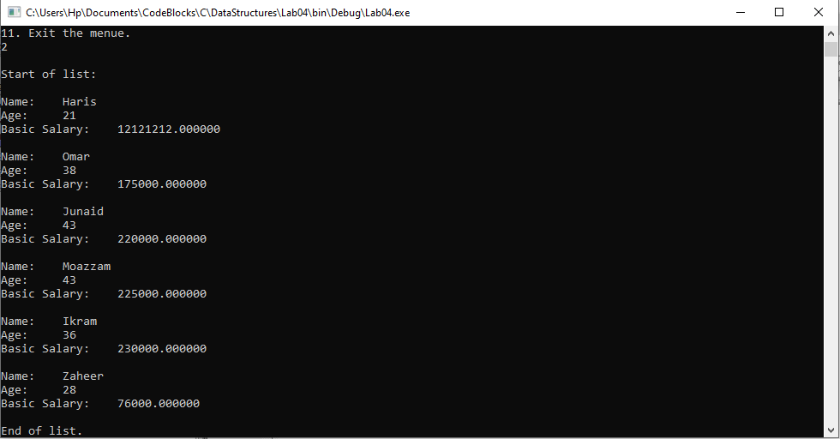

**PRINTING MEMORY MAP**

The code is shown below,

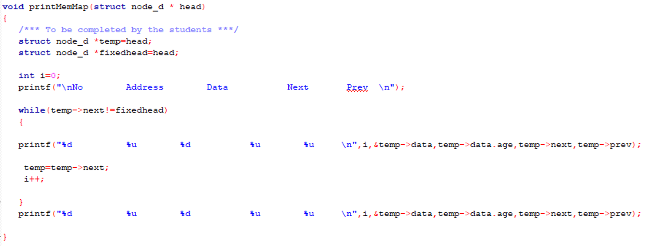

The Result of the following code is attached below:

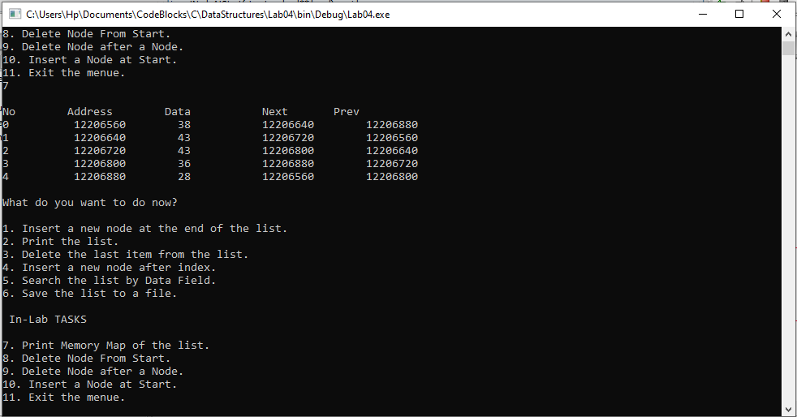

------------------------------

**POST LAB**

**Question no:3**

**Learn more about at the Josephus Problem from the following links and make a Circular Doubly Linked List simulation of this problem. (Your program should print the remaining people in each iteration).**

Solution

The code is shown below for the given program and its results are given below,

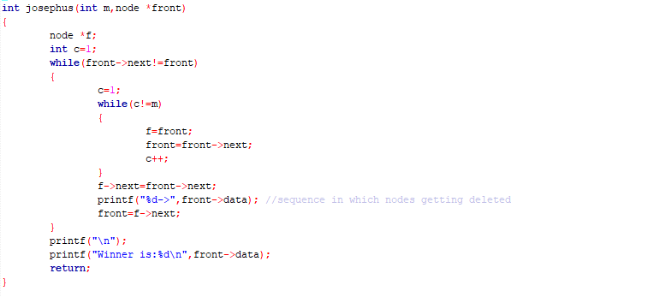

The Result of the following code is attached below:

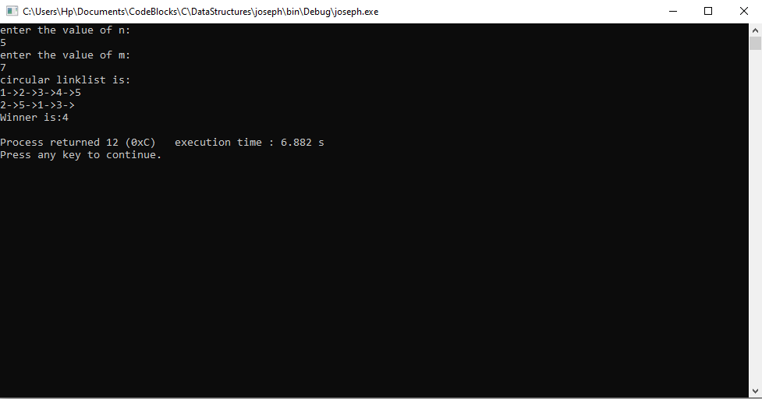

------------------------------

THE END